directions:
STUDIO one is conveniently located next to Princesshay Shopping Centre on Southernhay West
(third floor, no 23)

By car:
- There are plenty of car parks nearby serving the city centre.
Magdalen Rd is the most cost effective- about a ten-minute walk. The entrance is on Magdelen Rd. Walk to the bottom end of the car park, toward the left there is a short flight of steps, cross over the outer ring Rd and into Barnfield crescent, At the top of Barnfield Crescent you come out onto Southernhay- walk ahead as if going into the shopping centre, then just where the road leading into the shopping centre meets with Southernhay, turn left down the hill a few doors, to ‘no 23’ (Naomi Ryan Estate agent on the ground floor.)
- Princesshay Carpark is the nearest, about a five-minute walk. Come out of the entrance by Giraffe restaurant, then walk away from the shopping centre with Giraffe restaurant on your right, you will see Southernhay West going downhill on your right- walk down to no 23 on the right.

From Exeter Central station:(about a fifteen minute walk):
- Left out of station, walk past the RAM Museum, carry straight on – cross the main shopping Street, bear left onto the main shopping st, then right into the shopping centre - go past ‘Yo Sushi’ on your right- keep going straight on, go past ‘Neil’s Yard shop on your right and the rear entrance of Debenhams on your left, keep going, you will arrive at the junction of the shopping centre and Southernhay- turn right and we are a few doors down ‘no 23’ (Naomi Ryan Estate agent on the ground floor.)

From Paris St Bus station:( about a ten-minute walk)
Head for Princesshay shopping centre, then follow the directions above as if coming from Princesshay car park

(No 23 is First door down, by the black parking meter in the photo below)
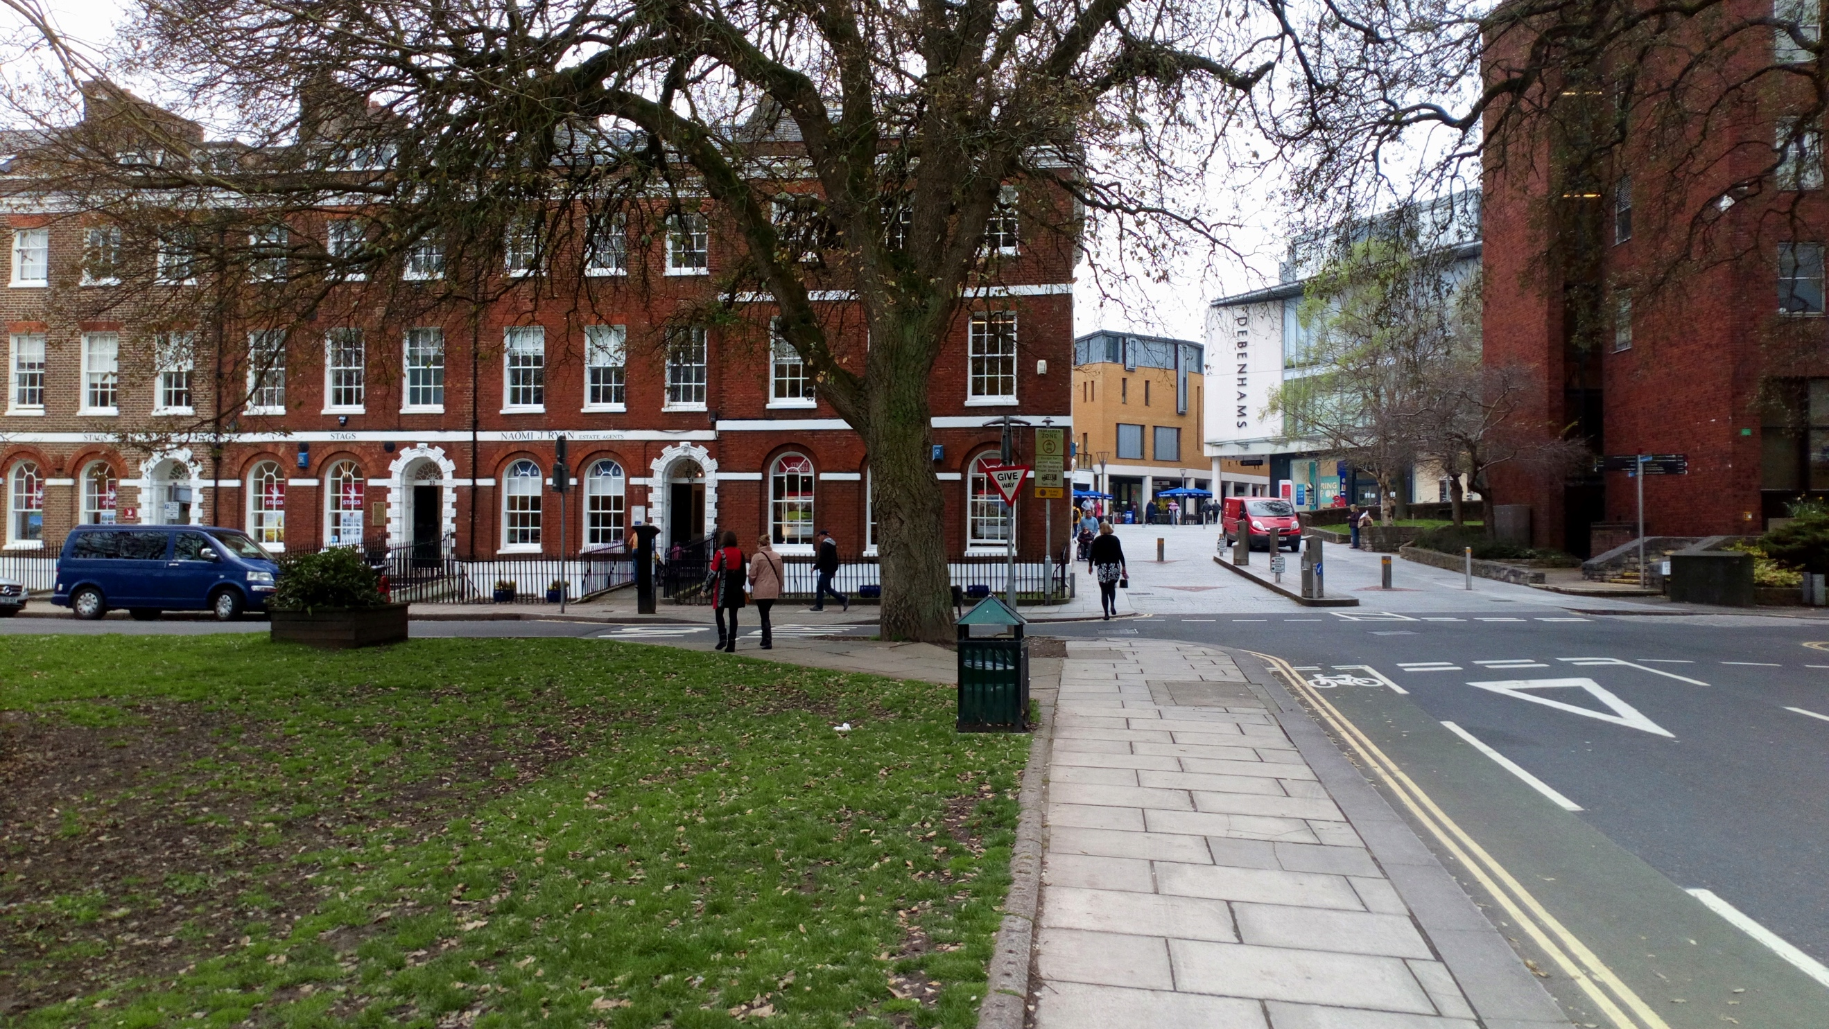

STUDIO one is on the top floor, (no lift).
The toilets are on the first floor, and you may wish to avail yourself of those before coming up (otherwise its two floors back down )

